**Chapter 1 - History of Chemistry**

**All Lectures Uploaded on YouTube:**

[**https://tinyurl.com/fkm10-chemistry**](https://tinyurl.com/fkm10-chemistry)



**1.1. Principles and Methods in Chemistry**

**(a) Conservation of Mass and Energy**

*Mass and energy cannot be created or destroyed in a closed system*.

For example, in a chemical reaction, the total mass of the reactants is always equal to the total mass of the products.

This principle, first demonstrated by Antoine Lavoisier in the 18th century, revolutionized the way chemists conduct experiments by making them more accurate and reliable. If an experiment doesn't follow this rule, chemists check their procedures and calculations to find what went wrong.

**(b) Using Observations and Logical Thinking**

*Chemists create theories and models based on what they observe in experiments. They use logical thinking to make sense of their findings.*

For example, Dmitri Mendeleev created the periodic table by observing patterns in the properties of elements. He even predicted elements that hadn't been discovered yet based on these patterns. This way of using evidence and reasoning is an important part of how science works.

**(c) Controlled Experiments**

*Chemists, like other scientists, use controlled experiments to test their ideas. They change one variable at a time while keeping others constant to see what happens*.

For example, in pharmaceutical chemistry, controlled experiments are used to test if new medicines work and are safe. This method is also used in other sciences, like biology and physics, to find cause-and-effect relationships.

**(d) Peer Review**

*Before scientific work is published, it is reviewed by other scientists to make sure it is correct and reliable. Chemists share their results in journals, where experts check the experiments, data, and conclusions for mistakes or unclear parts.*

For example, if a chemist discovers a new catalyst, it must be reviewed and tested by other scientists to confirm the findings. This process ensures the quality of scientific research.



**(e) Being Objective**

*In science, results must come from facts, not opinions or biases. Chemists aim to be objective when performing experiments and analyzing data.*

For example, when identifying the structure of a molecule using spectrometry, they rely on precise measurements and standard methods instead of guesses or personal beliefs.

**(f) Skepticism and Proof**

*Scientists are naturally skeptical and always double-check discoveries. They repeat experiments and have others test their work before accepting it.*

For example, if someone claims to discover a new element or reaction, other scientists will conduct many tests to verify it. This skepticism helps ensure that only trustworthy information becomes part of science.

**1.2. Evolution of Scientific Ideas (Paradigms)**

**What is a Scientific Paradigm?**

*A scientific paradigm is a set of ideas, methods, and rules that guide scientists in their research. It helps scientists understand the natural world and explain their discoveries. Paradigms give scientists a consistent way to study and share knowledge. However, when new evidence challenges an existing paradigm, it may be replaced with a better one.*

Here are some examples of scientific paradigms and how they changed over time:

**1. The Phlogiston Theory**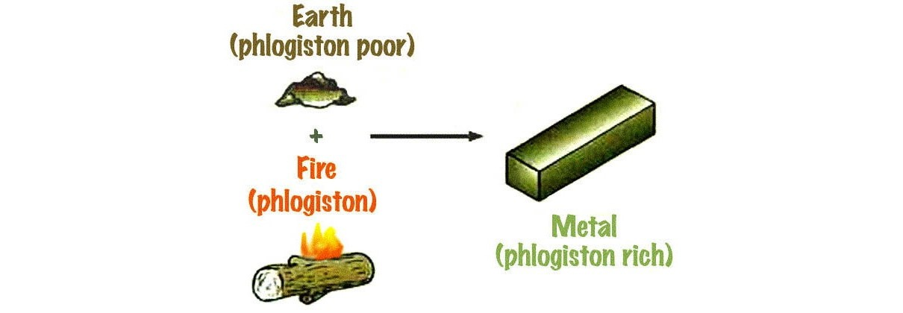

In the 1700s, scientists believed in the phlogiston theory to explain burning (combustion) and rusting. According to this idea, materials that could burn contained a substance called "phlogiston," which was released during burning. For example, when metals rusted, people thought they absorbed "deflogisticated air."

Later, Antoine Lavoisier proved that combustion happens because oxygen combines with substances, not because of phlogiston. His work introduced a new way of thinking about chemical reactions, replacing the phlogiston theory with the modern concepts of oxidation and reduction.

**2. Historical Models of the Atom**

Scientists have changed their ideas about what atoms look like as they learned more through experiments:

* The Plum Pudding Model (1904): J.J. Thomson suggested that atoms are like a "pudding" with negatively charged electrons (the "plums") scattered in a positively charged "soup."
* Rutherford's Model (1911): Ernest Rutherford's gold foil experiment showed that atoms have a small, dense, positively charged centre called a nucleus, with electrons orbiting around it.
* Bohr's Model and Quantum Model: Later, scientists improved Rutherford's model by adding ideas about energy levels (Bohr's model) and quantum mechanics, which is the current way we understand atoms.

**3. The Periodic Table**

Dmitri Mendeleev created the periodic table in 1869 to organize elements based on their atomic masses and properties. His table was powerful because it predicted the existence of elements that had not been discovered yet.

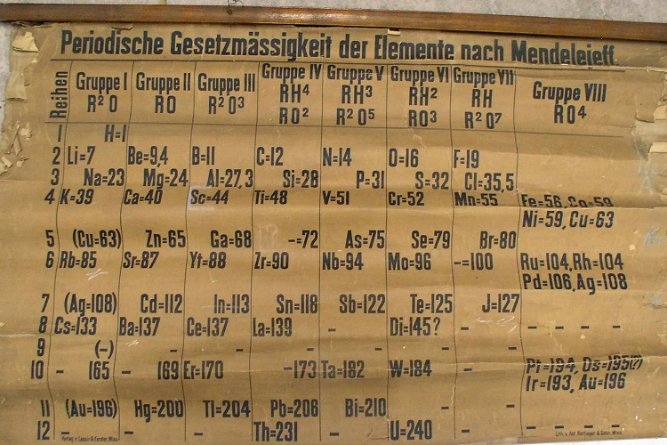

**Modern Periodic Table**

As scientists learned about atomic structure and quantum mechanics, they updated the periodic table. Today, elements are arranged based on their atomic numbers and electron configurations. This modern version explains why elements show similar chemical properties at regular intervals (periodicity) and helps us understand their behaviour in reactions.

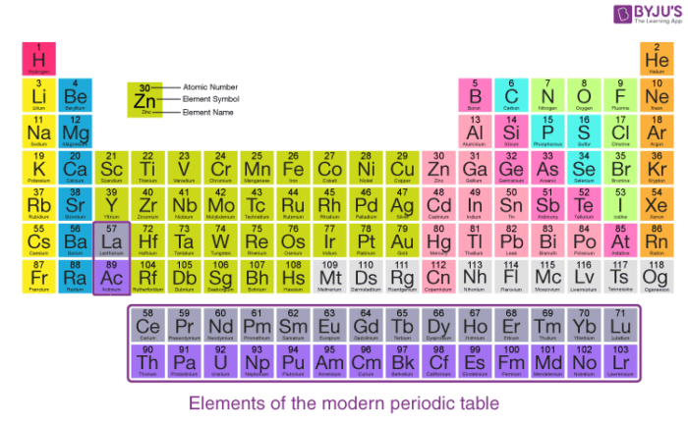

**1.3. Scientific Paradigms in Chemistry**

* Scientific paradigms in chemistry are **ideas and rules** that explain how substances behave and interact.
* These paradigms **guide scientists** in: Designing experiments, Testing ideas, Interpreting results
* They help expand knowledge about **existing materials**.
* They inspire the **creation of new materials and technologies**.
* They play an important role in advancing fields such as: **Medicine**, **Materials science** **Environmental protection**

**1.4. Confidence and Uncertainty in Chemistry**

Chemistry, like other sciences, involves both confidence and uncertainty when analyzing experimental results. Scientists use tools to measure how precise or reliable their data is:

**1. Confidence Intervals**

*Confidence intervals show how precise a measurement is*.

For example, if a pharmacist measures the concentration of a solution to be 0.50 molar with a 95% confidence interval (0.48-0.52 molar), it means they are 95% sure that the true value is within this range.

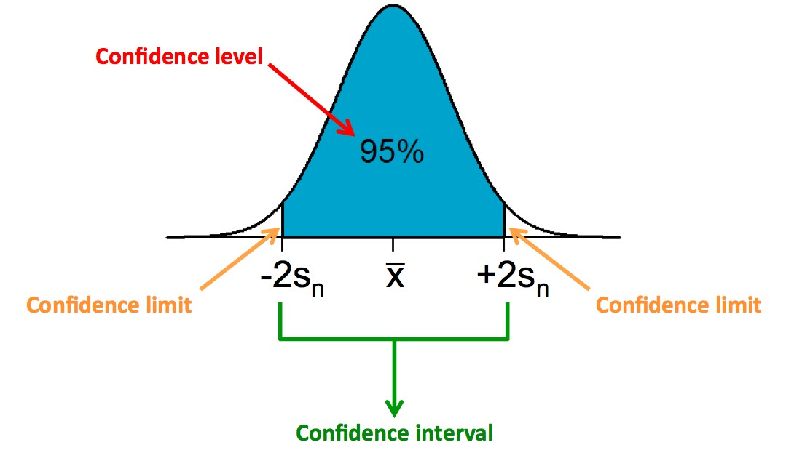

**2. P-Values**

*P-values help scientists check if experimental results are meaningful.*

For example, if a chemist tests whether a new catalyst works faster than an old one and finds a p-value of 0.01, it means there's only a 1% chance that the result is random. This shows the new catalyst is almost certainly better.

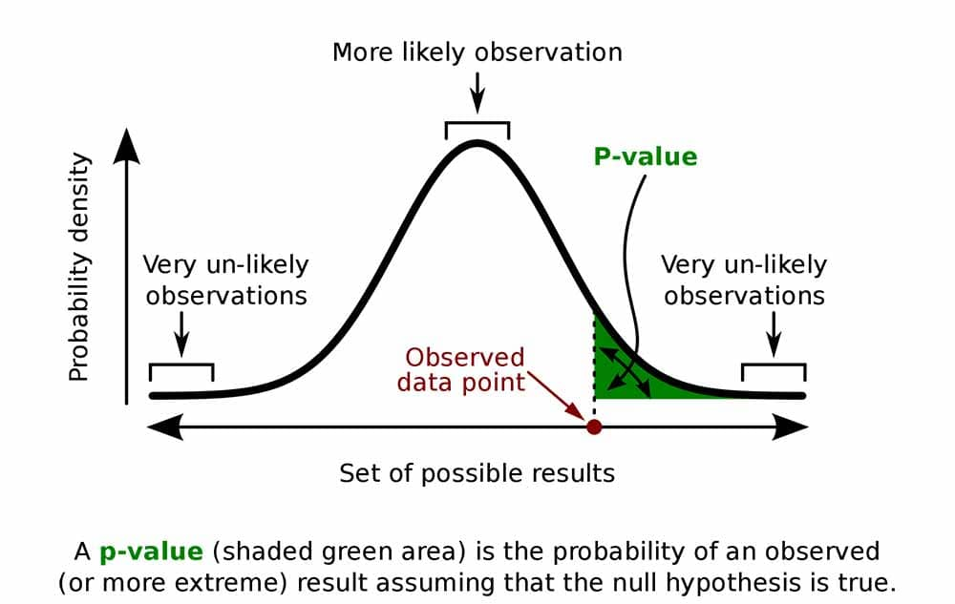

**3. Standard Error and Standard Deviation**

*These tools measure how much data varies.*

For example, if a chemist measures the melting point of a substance and finds the average is 120°C with a standard deviation of 0.5°C, it means the results are consistent. A small standard error (e.g., 0.1°C) shows that the average value is accurate.

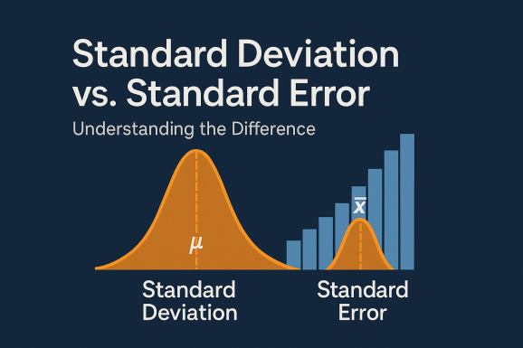

**4. Bayesian Probability**

*This method updates our confidence in an idea based on new evidence.* ***Bayesian probability*** *is an interpretation of probability that measures how strongly we believe something is true, based on the information we have — and then updates that belief when new evidence appears.*

For example, if a chemist first believes there's a 60% chance a reaction happens in a certain way, but new data raises their confidence to 80%, they've used Bayesian probability to update their understanding.

**5. Quantifying Uncertainty**

*Uncertainty tells us how reliable a measurement is.* ***Quantifying uncertainty*** *means measuring how unsure we are about a result or value by expressing it as a numerical estimate*.

For example, if a chemist measures the concentration of a solution as 0.250 molar ± 0.005 molar, the uncertainty is ±0.005 molar, meaning the true value is close to 0.250 molar.

**1.5. Repeatability and Reproducibility**

**Repeatability**

*This means getting the same result when repeating an experiment under the same conditions, using the same tools and procedures*.

For example, if a chemist measures the melting point of a substance several times in the same lab and gets the same result each time, the experiment is repeatable.

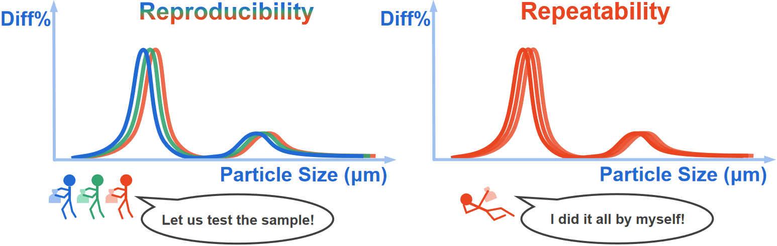

**Reproducibility**

*This means getting the same result even when the experiment is done in different labs, with different tools, methods, and scientists*.

For example, if different chemists in different labs measure the same substance's melting point and get similar results, the experiment is reproducible.

**Why Are These Important?**

• Repeatability shows that the experiment is well-controlled and consistent in one setting.

• Reproducibility shows that the findings are reliable and not limited to one lab or method. Both help scientists ensure their discoveries are accurate and accepted by others.

